**Strategic product placement analysis: unveiling sales impact with tableau visualization**

**MENTOR:K.RATHNA KUMARI MEDAM**

**TEAM ID: LTVIP2025TMID52624**

**TEAM DETAILS**

**TEAM LEADER:KOSURI LAKSHMI PRASANNA KUMARI**

****REG:SBAP0052624 EMAIL ID:karunakumarnani182@gmail.com

**TEAM MEMBERS:**

1.VANAPALLI ROHINI KALYANI

****REG:SBAP0052648 EMAIL ID:rohinikalyanichinni@gmail.com

2.BOTTA JAYA

REG:SBAP0052636 EMAIL ID:jayabotta70@gmail.com

3.EJJADA LAVANYA

REG:SBAP0052606 EMAIL ID:lavanyaejjada2@gmail.com

**TEAM GROUP**



Strategic Product Placement Analysis: Unveiling Sales Impact with Tableau Visualization

This project aims to investigate the relationship between product positioning, sales performance, and consumer behavior. Using Tableau, we will analyze data to uncover insights into how different positioning strategies impact sales and consumer preferences. By visualizing the data, we aim to provide actionable recommendations to optimize product positioning strategies and drive revenue growth.

A retail company wants to understand the impact of product positioning on its sales and consumer behavior. They have collected data on sales figures, product placement, and consumer demographics. They seek insights into which product positioning strategies are most effective in driving sales and how they can tailor their marketing efforts accordingly. Through data visualization with Tableau, the company hopes to gain actionable insights to improve its product positioning strategies and increase revenue.

Scenario 1. Film and Television Production Companies: Production companies can utilize strategic product placement analysis to optimize revenue generation through partnerships with brands. By employing Tableau visualization, they can analyze the effectiveness of product placements in different scenes or episodes. This analysis can help them negotiate better deals with brands, understand audience engagement with specific products, and make data-driven decisions on future placement opportunities.

Scenario 2. Retail and Consumer Goods Companies: Retailers and consumer goods companies can leverage strategic product placement analysis to enhance their marketing strategies and boost sales. By using Tableau visualization, they can track the performance of products placed in various locations within their stores or on their websites. They can identify high-traffic areas, understand customer preferences, and optimize product placement to increase visibility and drive conversions.

Scenario 3. Advertising Agencies: Advertising agencies can benefit from strategic product placement analysis to provide valuable insights to their clients and optimize advertising campaigns. By utilizing Tableau visualization, they can analyze the impact of product placements in different media channels such as movies, TV shows, or online videos. This analysis can help them demonstrate the ROI of product placement initiatives, refine targeting strategies, and improve campaign effectiveness for their clients.

### Technical Architecture

### kkr.png

### Project Flow

To accomplish this, we have to complete all the activities listed below,

?   Data Collection & Extraction from Database

o   Collect the dataset

o   Connect data with Tableau

?    Data Preparation

o   Prepare the Data for Visualization

?    Data Visualizations

o   No of Unique Visualizations

?    Dashboard

o   Responsive and Design of Dashboard

?    Story

o   No of Scenes of Story

?    Performance Testing

o   Utilization of Data Filters

o   No of Calculation Fields

o   No of Visualizations/ Graphs

?   Web Integration

o   Dashboard and Story embed with UI With Flask

?    Project Demonstration & Documentation

o   Record explanation Video for project end-to-end solution

o   Project Documentation-Step step-by-step project development procedure

### Data Collection and Extraction of Data

Data collection is the process of gathering and measuring information on variables of interest, in an established systematic fashion that enables one to answer stated research questions, test hypotheses, and evaluate outcomes, and generate insights from the data.

Collect the dataset

Please use the link to download the dataset:  
  
<https://www.kaggle.com/datasets/amitvkulkarni/impact-of-product-positioning-on-sales>

Understanding the Data

The dataset includes information on sales data, product positioning, and consumer behavior metrics. It contains variables such as product placement (endcap, aisle, shelf), sales revenue, customer demographics, product attributes, and promotional activities. The dataset covers a range of products and periods, allowing for a comprehensive analysis of the impact of product positioning on sales and consumer behavior.

1. Product ID: A unique identifier assigned to each product in the dataset.
2. Product Position: The relative placement or ranking of the product within its category(endcap, aisle, shelf)of the market.
3. Price: The selling price of the product.
4. Competitor's Price: The price at which competitors are selling a similar product.
5. Promotion: Any special offers, discounts, or promotions associated with the product.
6. Foot Traffic: The volume of people passing by or visiting the location where the product is sold.
7. Consumer Demographics: Characteristics and traits of the target audience (Families, Seniors, Young adults, and College students) or consumers purchasing the product.
8. Product Category: The broad category or type of product to which it belongs.
9. Seasonal: Indicates whether the product is seasonal or not seasonal.
10. Sales Volume: The quantity of units sold for the product over a specific period.

### Connecting the dataset with Tableau

To visualize the dataset in Tableau, import the dataset file into Tableau Desktop. Then, link the relevant columns to Tableau's data fields to create visualizations and analyze the data effectively.

ReferenceVideo:   
<https://drive.google.com/file/d/1cS7Ork8XG7c_RjdmMW_EwZqQj6cwgn9x/view?usp=sharing>

### Data Preparation

Preparing data for visualization is a crucial step in the data analysis pipeline, involving various tasks to ensure the quality and usability of the dataset. Initially, cleaning the data is essential, which entails identifying and removing irrelevant or missing data points that could skew the analysis. Transforming the data into a format conducive to visualization involves organizing it in a structured manner, standardizing units of measurement, and converting categorical variables into numerical ones where necessary.

### Prepare the Data for Visualization

Exploring the data is another vital aspect of preparation, where analysts delve into the dataset to uncover underlying patterns, trends, and relationships among variables. This exploration aids in determining which aspects of the data are most relevant for visualization and analysis. Filtering the data allows analysts to focus on specific subsets or segments of the dataset, refining the scope of analysis and visualization to address particular questions or objectives.

## Once the data is cleaned, transformed, explored, and filtered, it is prepared for integration into visualization software such as Tableau. This involves formatting the data according to the requirements of the software and ensuring compatibility with the chosen visualization techniques. Additionally, ensuring the accuracy and completeness of the data is paramount throughout the preparation process, as any inaccuracies or omissions could lead to erroneous conclusions during analysis.

### Data Visualization

* Data visualization is the process of creating graphical representations of data in order to help people understand and explore the information. The goal of data visualization is to make complex data sets more accessible, intuitive, and easier to interpret. By using visual elements such as charts, graphs, and maps, data visualizations can help people quickly identify patterns, trends, and outliers in the data.

### No of Unique Visualizations

The number of unique visualizations that can be created with a given dataset. Some common types of visualizations that can be used to analyze the performance and efficiency of Product Placement include bar charts, Stacked Bar charts, heat maps, Donut charts, Bubble charts, pie charts, etc. These visualizations can be used to compare performance, track changes over time, and show distribution, and relationships between variables, such as revenue and customer demographics, Competitors' price, Product Category, Product Position, Season, and Promotion.

Activity 1.1: Avg Sales Volume vs Product Category

Explanation Video Link:

<https://drive.google.com/file/d/1U7VKPbMDP1aTYd1KLdk284DZGPgJXkQF/view?usp=drive_link>

Activity 1.2: Competitor Price Vs Price

Explanation Video Link:

<https://drive.google.com/file/d/1mzcXYYd1Sv3WXWnt8fzqkpCC5c9M3MPM/view?usp=drive_link>

Activity 1.3: Avg Sales Volume by Product Category by Product Position

Explanation Video Link:

<https://drive.google.com/file/d/1HBeHTh_XHriqfFR7dsJTP-jTPuEyS9fV/view?usp=drive_link>

Activity 1.4: Consumer Demographics vs  Sales Volume

Explanation Video Link:

<https://drive.google.com/file/d/1laY_qirn7JN1kTGs3bVKEpl1085pYHmr/view?usp=drive_link>

Activity 1.5: Product Category vs Price

Explanation Video Link:

<https://drive.google.com/file/d/1-BUwN1kuJguZ6eQV6vvT6g9ysZxYx4cY/view?usp=drive_link>

Activity 1.6: Avg Sales Volume by Product Category by Season

Explanation Video Link:

<https://drive.google.com/file/d/12E_h12OOvQuHBoknh19e8MIBvLKs8ySq/view?usp=drive_link>

Activity 1.7: Foot Traffic  by Avg Sales Volume

Explanation Video Link:

<https://drive.google.com/file/d/17PbnYEKHEfuzOFBLhp9pTz9UkhYoZd1S/view?usp=drive_link>

Activity 1.8: Promotion of Product Category on Price and Sales Volume

Explanation Video Link:

<https://drive.google.com/file/d/1N-BwMnpxj87BrH86GpBwn5W_z8MxWEaV/view?usp=drive_link>

### Dashboard

A dashboard is a graphical user interface (GUI) that displays information and data in an organized, easy-to-read format. Dashboards are often used to provide real-time monitoring and analysis of data and are typically designed for a specific purpose or use case. Dashboards can be used in a variety of settings, such as business, finance, manufacturing, healthcare, and many other industries. They can be used to track key performance indicators (KPIs), monitor performance metrics, and display data in charts, graphs, and tables.

### Responsive and Design of Dashboard

The responsiveness and design of a dashboard for analyzing the performance and efficiency of Product Placement is crucial to ensure that the information is easily understandable and actionable. Key considerations for designing a responsive and effective dashboard include user-centered design, clear and concise information, interactivity, data-driven approach, accessibility, customization, and security. The goal is to create a dashboard that is user-friendly, interactive, and data-driven, providing actionable insights to improve the performance and efficiency of Product Placement Analysis.

Once you have created views on different sheets in Tableau, you can pull them into a dashboard.

Explanation Video Link:

<https://drive.google.com/file/d/1u67ecEyQz7XswgekZnpdHAE5sEhy79rS/view?usp=drive_link>

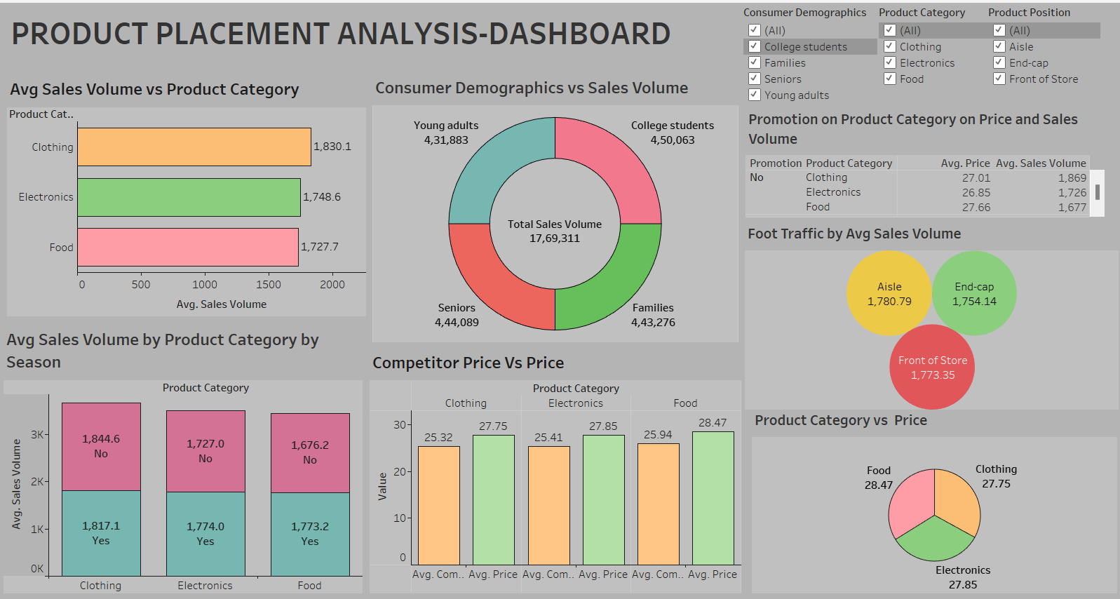

### Responsive and Design of Dashboard

The responsiveness and design of a dashboard for analyzing the performance and efficiency of Product Placement is crucial to ensure that the information is easily understandable and actionable. Key considerations for designing a responsive and effective dashboard include user-centered design, clear and concise information, interactivity, data-driven approach, accessibility, customization, and security. The goal is to create a dashboard that is user-friendly, interactive, and data-driven, providing actionable insights to improve the performance and efficiency of Product Placement Analysis.

Once you have created views on different sheets in Tableau, you can pull them into a dashboard.

Explanation Video Link:

<https://drive.google.com/file/d/1u67ecEyQz7XswgekZnpdHAE5sEhy79rS/view?usp=drive_link>

### Story

A data story is a way of presenting data and analysis in a narrative format, intending to make the information more engaging and easier to understand. A data story typically includes a clear introduction that sets the stage and explains the context for the data, a body that presents the data and analysis logically and systematically, and a conclusion that summarizes the key findings and highlights their implications. Data stories can be told using a variety of mediums, such as reports, presentations, interactive visualizations, and videos.

### No of Scenes of Story

The number of scenes in a storyboard for a data visualization analysis of the performance and efficiency of Product Placement will depend on the complexity of the analysis and the specific insights that are trying to be conveyed. A storyboard is a visual representation of the data analysis process and it breaks down the analysis into a series of steps or scenes.

Explanation Video Link:

<https://drive.google.com/file/d/15Q105EwhPRdJiEuYl6q9I7lxqZk8HYWo/view?usp=drive_link>

STORY SCENE-1

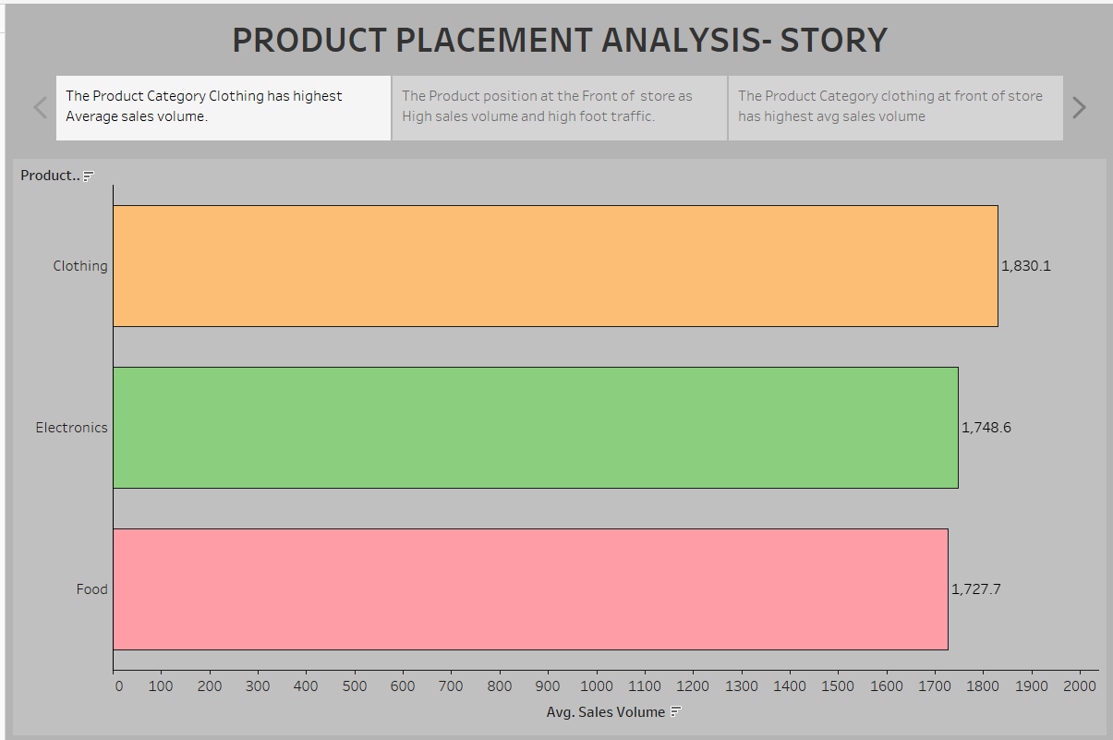

### STORY SCENE-2 kkl.png

STORY SCENE-3

### kko.png

### Performance Testing

Performance testing is a crucial aspect of software development aimed at evaluating the speed, responsiveness, stability, and scalability of an application under various workload conditions. It involves simulating real-world usage scenarios to assess how the system behaves and performs under stress, peak loads, or normal conditions.

### Utilization of Filters

1. Filters are an indispensable tool in data analysis and visualization, allowing users to refine and focus on specific subsets of data that are relevant to their analysis objectives.

### kol.png

### klo.png

No of Calculation Fields

* Price
* Competitors Price
* Sales Volume

### No of Visualizations/ Graphs

 Avg Sales Volume by Product Category  
? Avg Sales Volume by Product Category on Sales  
? Consumer Demographics vs Product Category   
? Foot traffic vs Sales Volume  
? Competitors Price vs Price.  
? Promotion of Product Category on Price and Sales Volume.  
? Product Category vs Price   
? Avg Sales Volume by Product Category by Product Position.

### Web integration

Publishing helps us to track and monitor key performance metrics, to communicate results and progress. help a publisher stay informed, make better decisions, and communicate their performance to others.

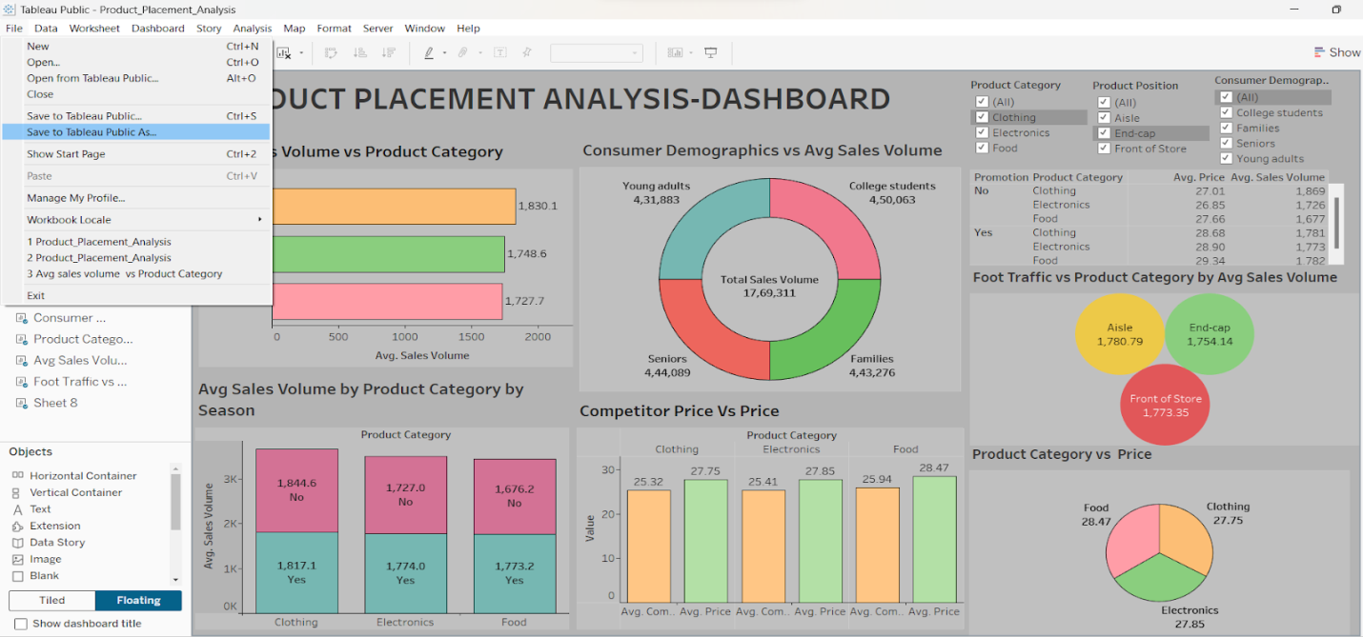

The above gives information on how to save and publish the dashboard to the tableau public.

* Click on  “File” which is displayed on the left top corner of the dashboard sheet.
* Now click on the Save as Tableau Public As option and that will redirect to your sign-in account as shown below.

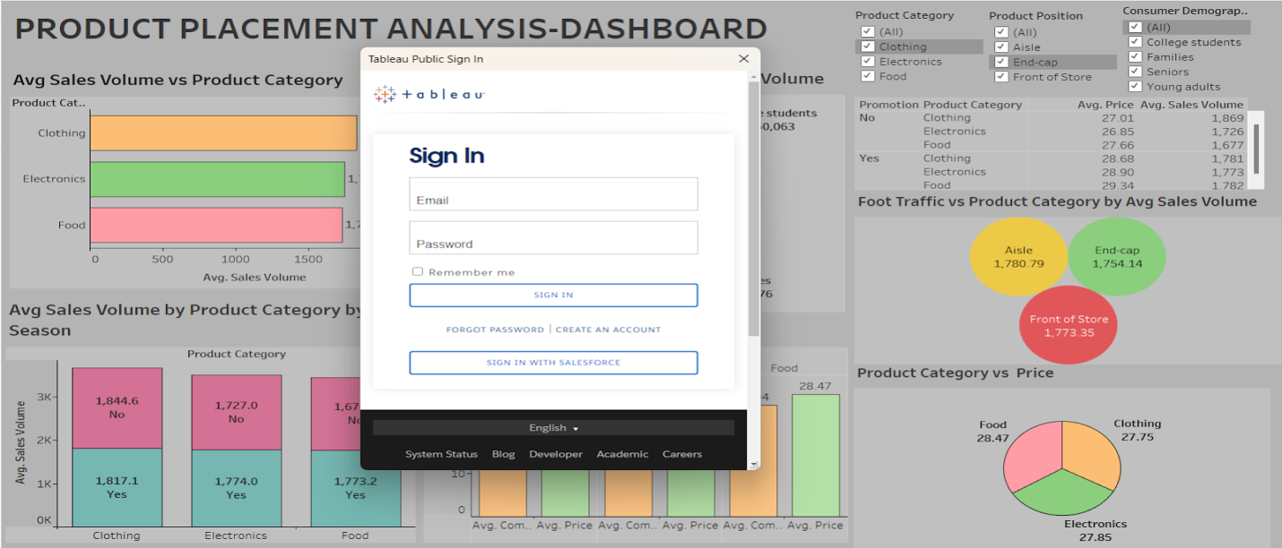

Now sign in to your Tableau public account and there your visualization, dashboard, and story are published. In this way, we can publish your dashboard and story into your tableau public.

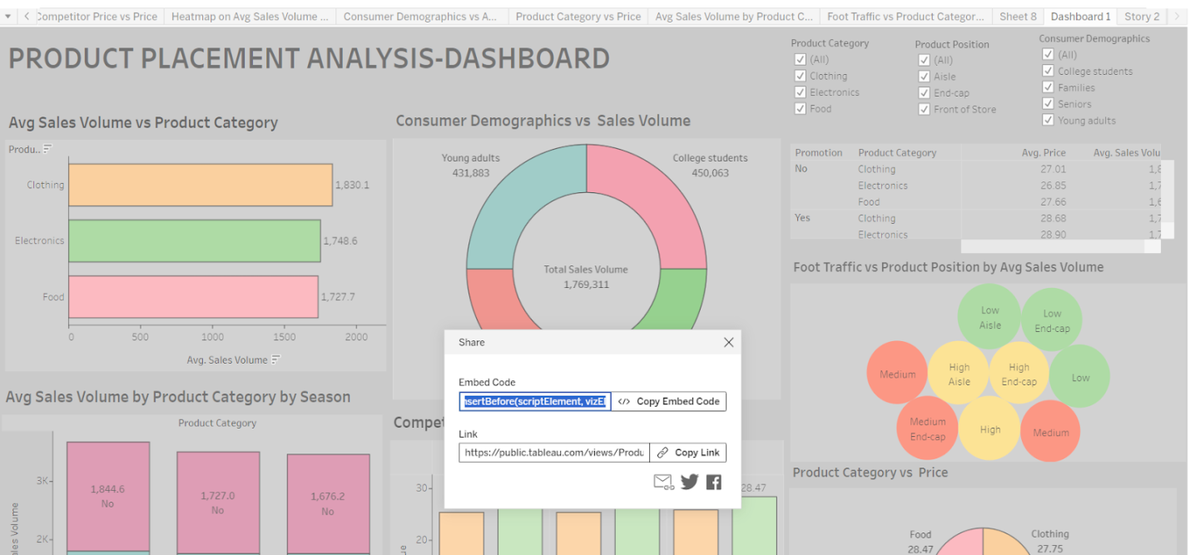

After signing into your public account the workbook is displayed. Now click on “settings” and then it will display to show sheets are disabled so enable it so, that all your sheets are visible.

Now click on the dashboard sheet in the top right corner we have an option called share click on it then it will show like the above screenshot. Then, copy the embedded code and place the copied embedded code into your bootstrap template as shown in the reference video below.

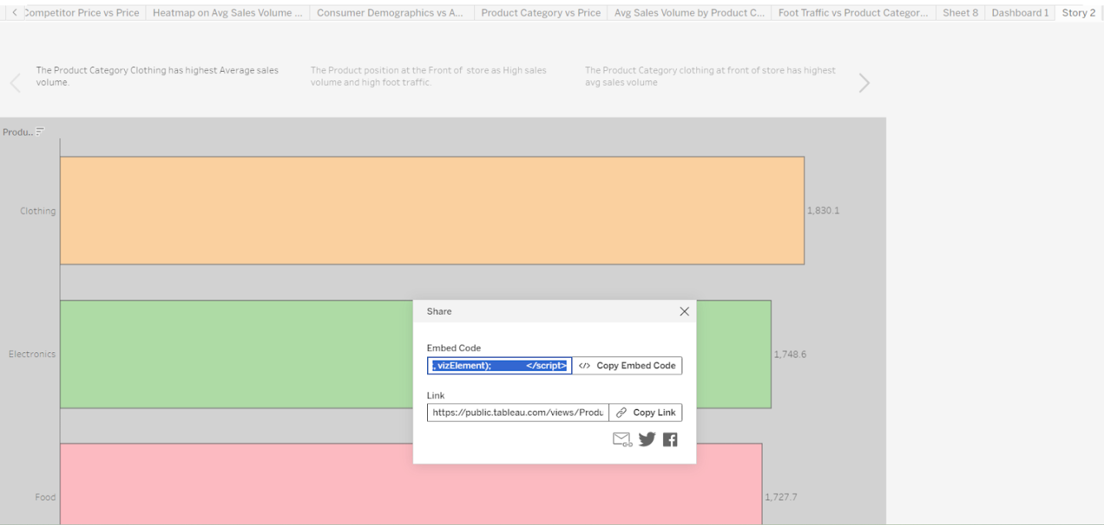

After copying the embedded code of the dashboard from Tableau Public and pasting it in the Bootstrap template then use the same procedure for the story also to copy the embedded code from the Tableau Public and paste it into the Bootstrap template.

### Dashboard and Story embed with UI With Flask

Explanation Video Link:

<https://drive.google.com/file/d/1-ImErECS0qUz3dOHx901QKa5HXGTGkdl/view?usp=drive_link>

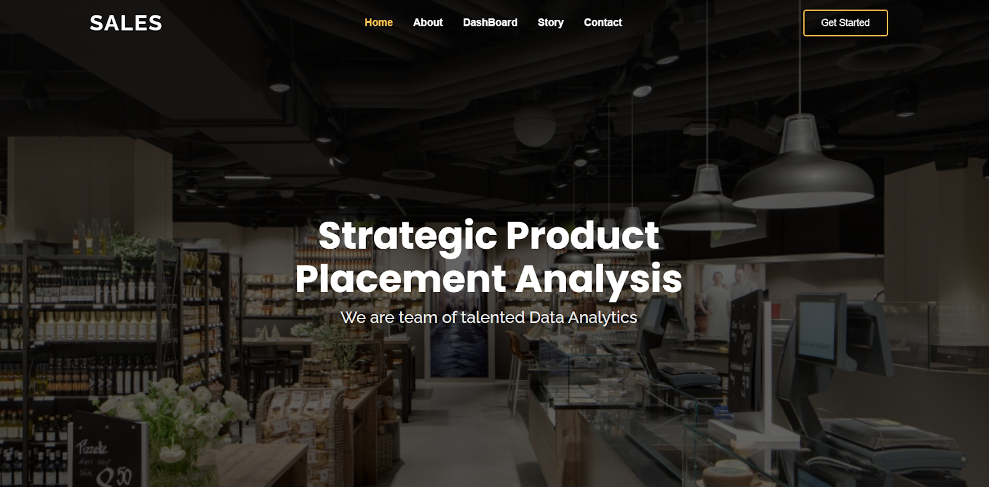

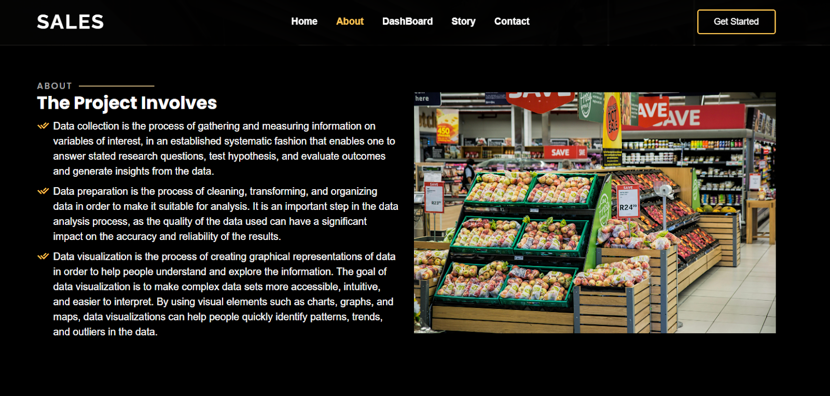

DASHBOARD

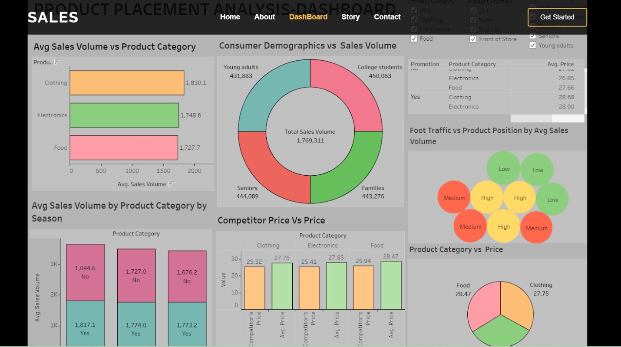

STORY SCENE-1

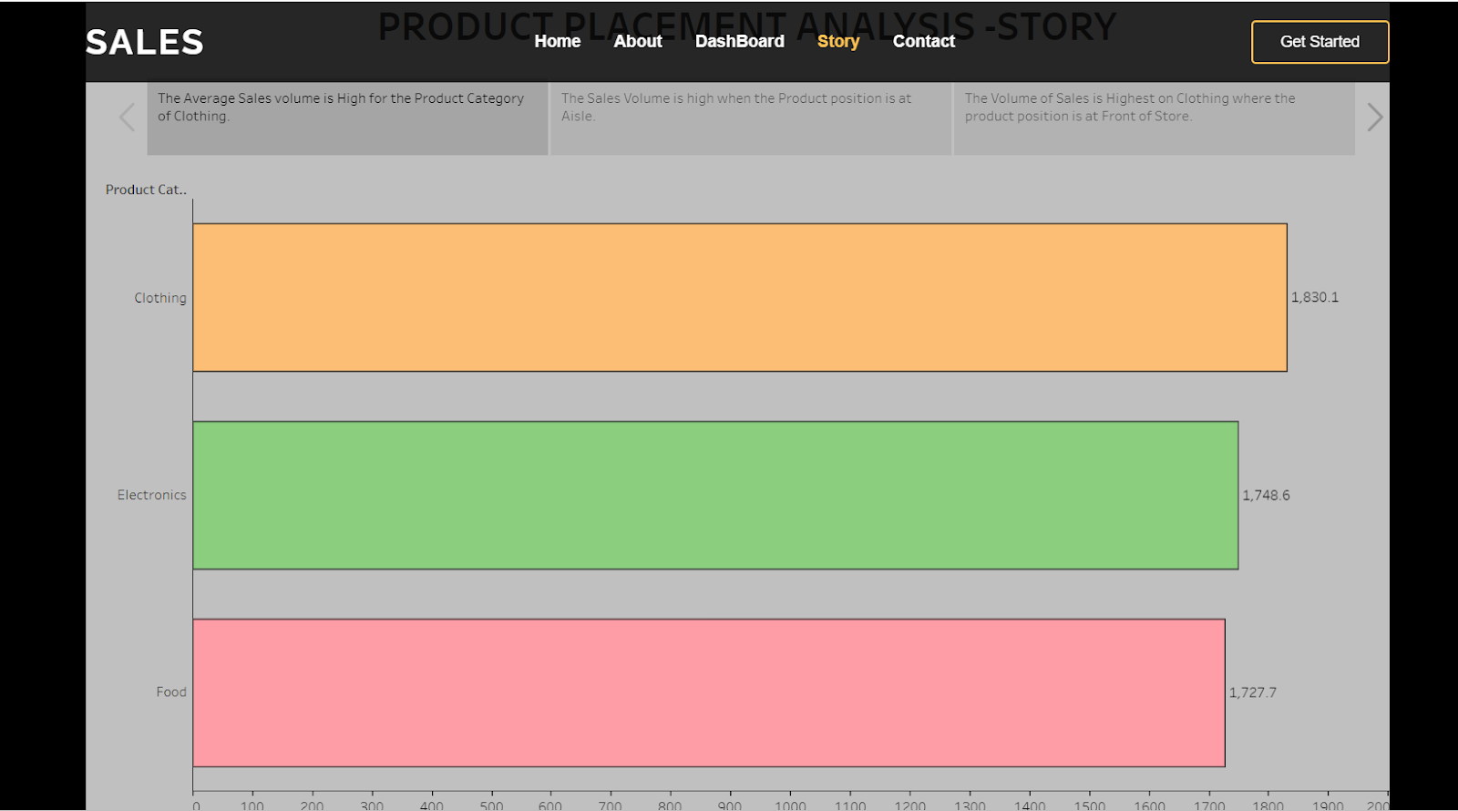

STORY SCENE-2

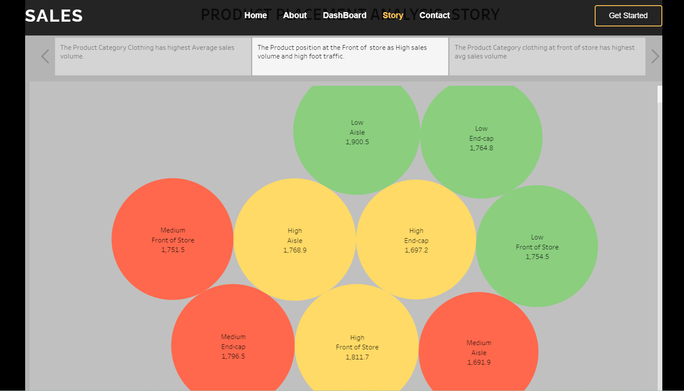

STORY SCENE-3

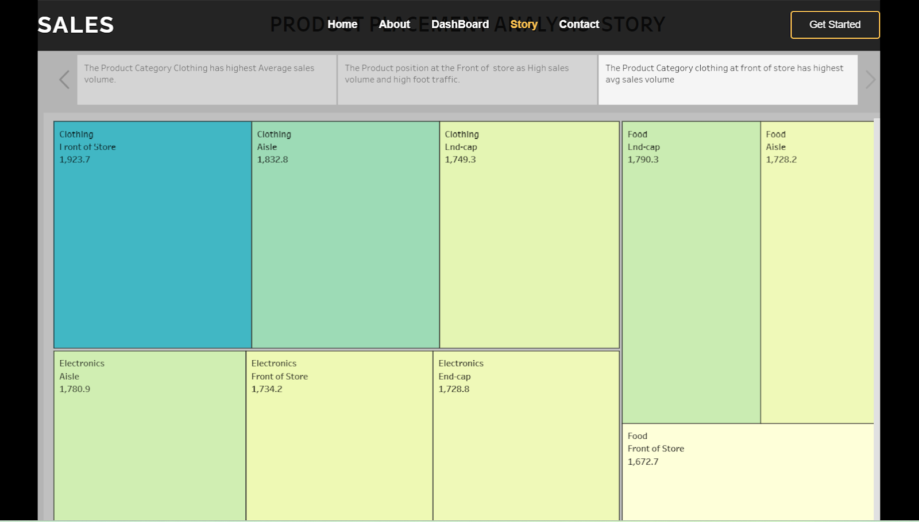

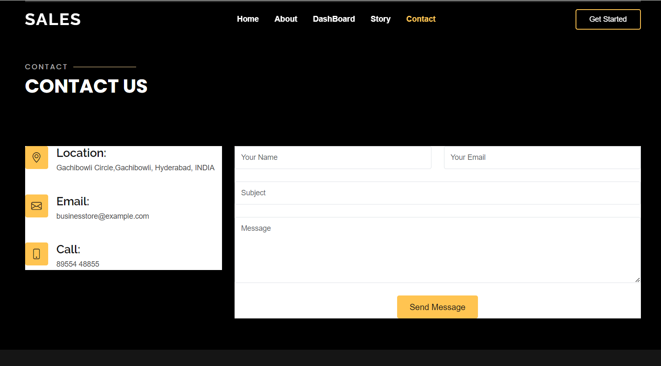

### Project Demonstration & Documentation

The mentioned deliverables are to be submitted along with other deliverables

Record an explanation Video for the project end to end solution

Creating a record explanation video for a project's end-to-end solution is crucial for ensuring clarity and transparency in its implementation.

Project Documentation-Step by step project development procedure

Create a document as per the template provided

## Clean Data from Excel, CSV, PDF, and Google Sheets with Data Interpreter

*Applies to: Tableau Cloud, Tableau Desktop, Tableau Server*

When you track data in Excel spreadsheets, you create them with the human interface in mind. To make your spreadsheets easy to read, you might include things like titles, stacked headers, notes, maybe empty rows and columns to add white space, and you probably have multiple tabs of data too.

When you want to analyze this data in Tableau, these aesthetically pleasing attributes make it very difficult for Tableau to interpret your data. That’s where Data Interpreter can help.

**Tip:** Though Tableau's Excel add-in is no longer supported, Data Interpreter can help you reshape your data for analysis in Tableau.

## What does Data Interpreter do?

Data Interpreter can give you a head start when cleaning your data. It can detect things like titles, notes, footers, empty cells, and so on and bypass them to identify the actual fields and values in your data set.

It can even detect additional tables and sub-tables so that you can work with a subset of your data independently of the other data.

After Data Interpreter has done its magic, you can check its work to make sure it captured the data that you wanted and identified it correctly. Then, you can make any necessary adjustments.

After you select the data that you want to work with, you might also need to do some additional cleaning steps like pivoting your data, splitting fields, or adding filters to get the data in the shape you want before starting your analysis.

**Note**: If your data needs more cleaning than what Data Interpreter can help you with, try [Tableau Prep(Link opens in a new window)](https://www.tableau.com/products/prep).

## Turn on Data Interpreter and review results

1. From the **Connect** pane, connect to an Excel spreadsheet or other connector that supports Data Interpreter such as Text (.csv) files, PDF files or Google sheets.
2. Drag a table to the canvas (if needed), then on the **Data Source** page, in the left pane, select the **Use Data Interpreter** check box to see if Data Interpreter can help clean up your data.

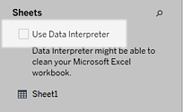

**Note:** When you clean your data with Data Interpreter, Data Interpreter cleans all the data associated with a connection in the data source. Data Interpreter does not change the underlying data.

1. In the Data pane, click the **Review the results** link to review the results of the Data Interpreter.

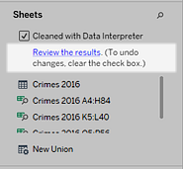

A copy of your data source opens in Excel on the **Key for the Data Interpreter** tab. Review the key to find out how to read the results.

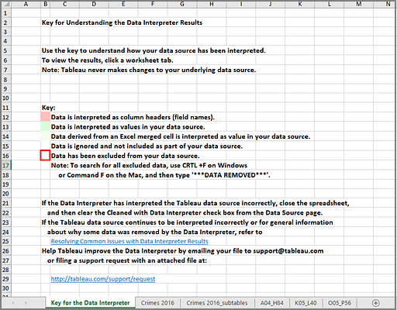

1. Click each tab to review how Data Interpreter interpreted the data source.

If Data Interpreter found additional tables, also called found tables or sub-tables, they are identified in the <sheet name>_subtables tab by outlining their cell ranges. A separate tab is also included for each sub-table, color coded to identify the header and data rows.

If Data Interpreter does not provide the expected results, clear the **Cleaned with Data Interpreter** check box to use the original data source.

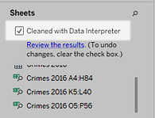

1. To replace the current table with any of the found tables, drag the current table off the canvas and then drag the found table that you want to use to the canvas.

If Data interpreter has misidentified the range of the found table, after you drag the found table to the canvas, click the drop-down arrow on that table, and then select **Edit Found Table** to adjust the corners of the found table (the top-left cell and bottom-right cell of the table).

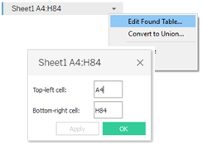

1. After you have the data that you want to work with, you can apply any additional cleaning operations to your data so that you can analyze it.

### Data Interpreter Example

In this example we are connecting to an Excel spreadsheet with violent crime data by city and state for the year 2016. This spreadsheet includes multiple tables on one sheet and some extra formatting.

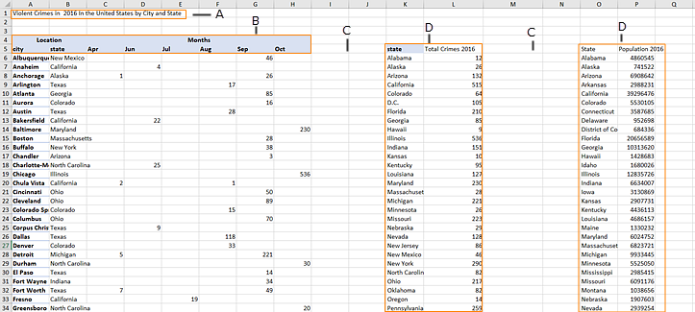

1. Title
2. Merged header cells
3. Extra white space
4. Sub-tables

The extra formatting in this spreadsheet makes it difficult for Tableau to determine what the field headers and values are.

Instead, it reads the data vertically and assigns each column the default value F1, F2, F3 (Field 1, Field 2, Field 3) and so on. Blank cells are read as null values.

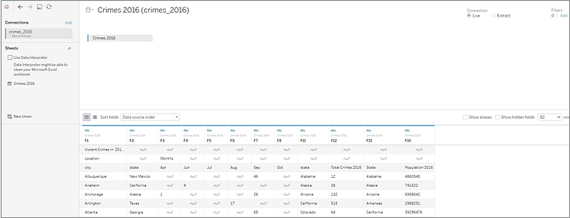

To see if Data Interpreter can help clean this data set, we select **Use Data Interpreter**.

Data Interpreter detected the proper headings for the fields, removed the extra formatting and found several sub-tables. The sub-tables are listed in the **Sheets** section in the Data pane and are named using the original sheet name and the cell ranges for each sub-table.

In this example there are three sub-tables: **Crimes 2016 A4:H84**, **Crimes 2016 K5:L40**, and **Crimes 2016 O5:P56**.

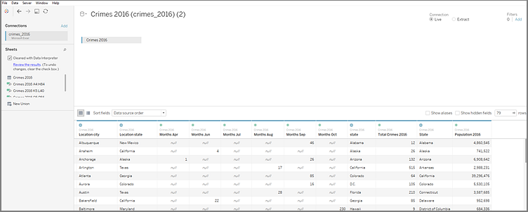

To examine the results of the Data Interpreter more closely, we click the **Review the results** link in the Data pane to view an annotated copy of the spreadsheet.

Here we see a copy of the original data, color coded to identify which data was identified as header data and which data was identified as field values.

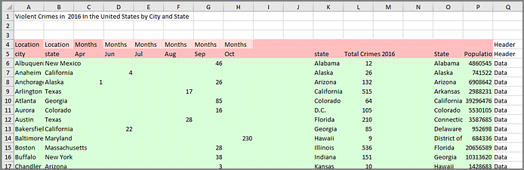

The next tab shows us the sub-tables that Data Interpreter found, outlined by the cell ranges.

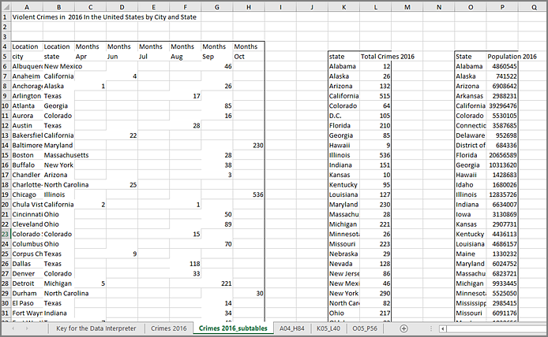

In this example the first sub-table, **Crimes 2016 A4:H84**, has the main data that we want to work with. To use this table as our data table, we can simply drag the original table off the canvas and then drag the new table to the canvas.

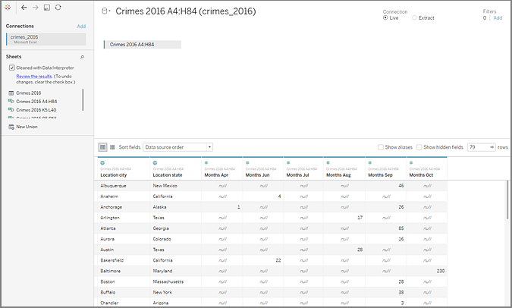

Once we have the data that we want to work with in the canvas, we can do some additional clean up on the data. For example we can:

* Change the field names so that they represent city, state, and month names.
* Pivot the months fields.
* Drag in the third sub-table **Crimes 2016 o5:P56** and join it to our first sub-table on the **State** field to include state populations for our analysis.
* Hide any duplicate fields that were added as a result of the join.

The results might look something like this:

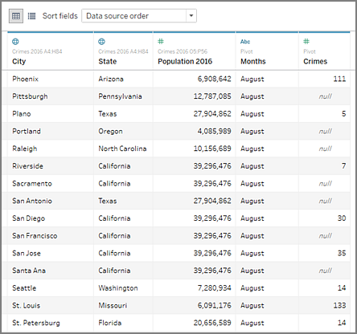

Now we are ready to start analyzing our data in Tableau.

## When Data Interpreter is not available

The Data Interpreter option might not be available for the following reasons:

* **The data source is already in a format that Tableau can interpret:** If Tableau Desktop doesn't need extra help from Data Interpreter to handle unique formatting or extraneous information, the Data Interpreter option is not available.
* **Many rows or many columns:** The Data Interpreter option is not be available when your data has the following attributes:
  + Data contains more than 2000 columns.
  + Data contains more than 3000 rows and more than 150 columns.
* **The data source is not supported:** Data Interpreter is only available for Microsoft Excel, Text (.csv) files, PDF files and Google Sheets. For Excel, your data must be in the .xls or .xlsx format.